TAPE EASE SUPPLY LLC QUALITY, SERVICE AND SELECTION*

Web site www.tapeease.com
PO Box 816 Phone (920) 863-3571
Denmark, WI 54227 Free 888-443-3461
E-mail: info@tapeease.com Fax(920) 863-3570

E-mail: info@tapeease.com

Web site www.tapeease.com

C6 Counterbalance Assembly Instructions. *Custom components will vary

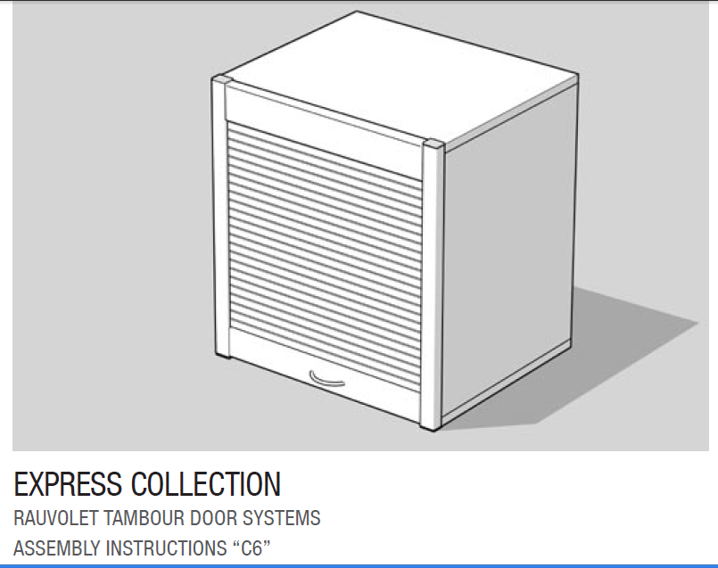

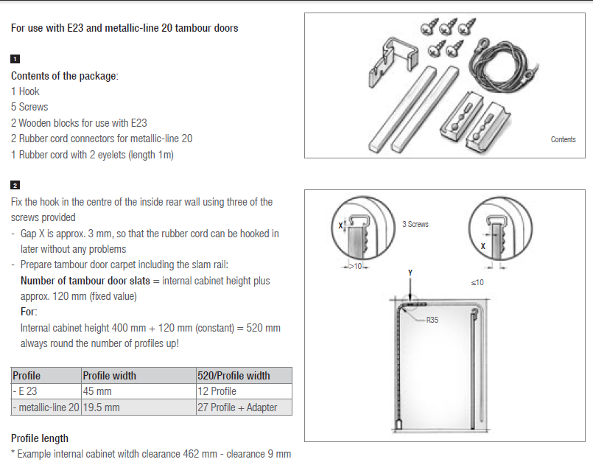

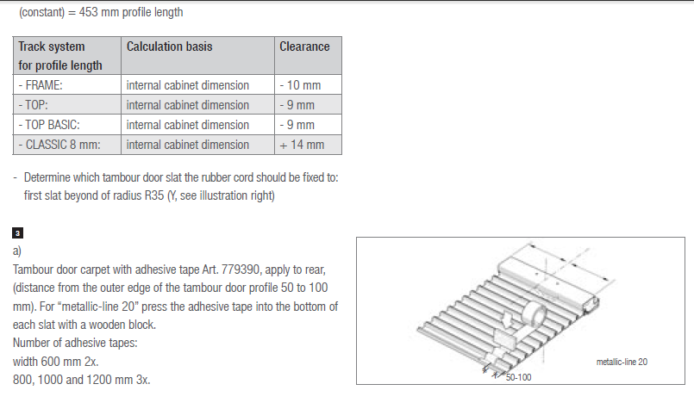
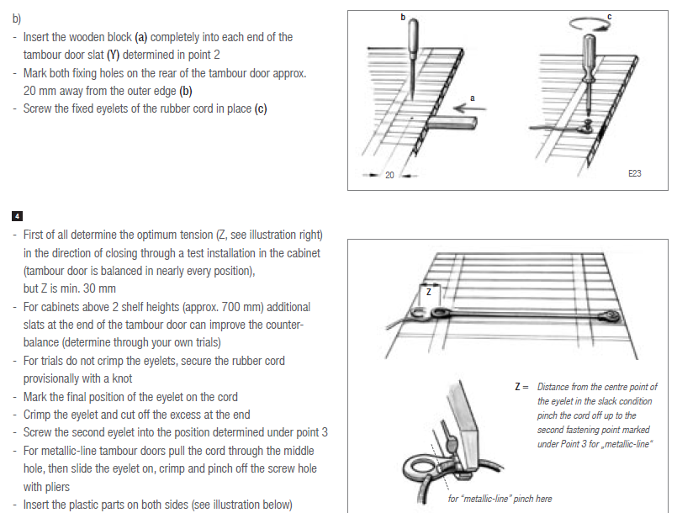
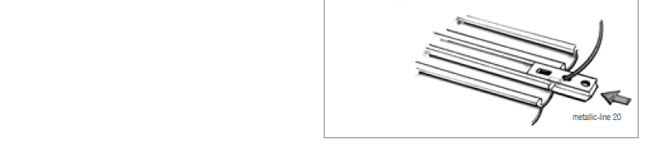

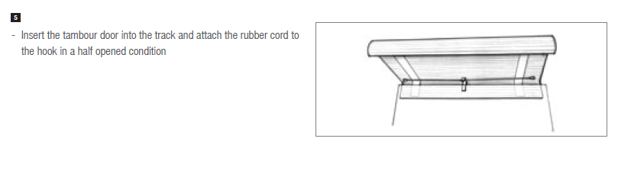

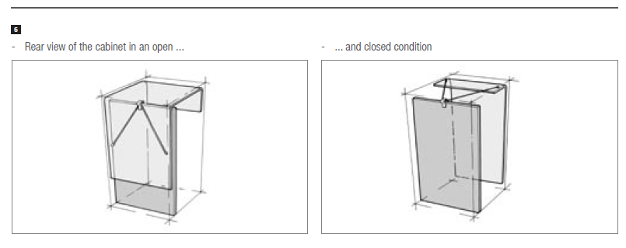
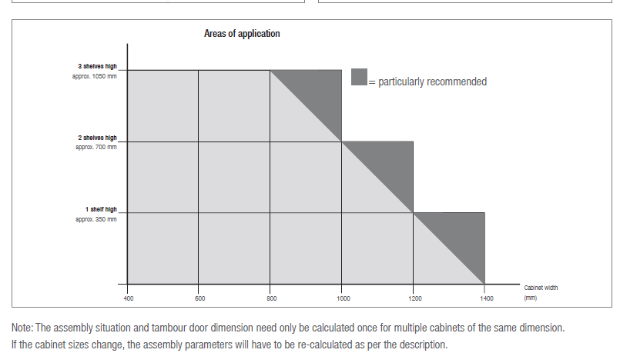

TAPE EASE SUPPLY LLC

